How to get started in Ruby on Rails with an IDE and Docker

Table of Contents:

1. _IDE
   1. Needed extensions
2. _Command_Line_Tools
3. _Docker
   1. Guide to building your project in Docker

## IDE

* It is suggested that you use VS Code, as it allows you to run a terminal in your IDE, making one less thing needed up on your screen.
* Go to: <https://code.visualstudio.com/download>

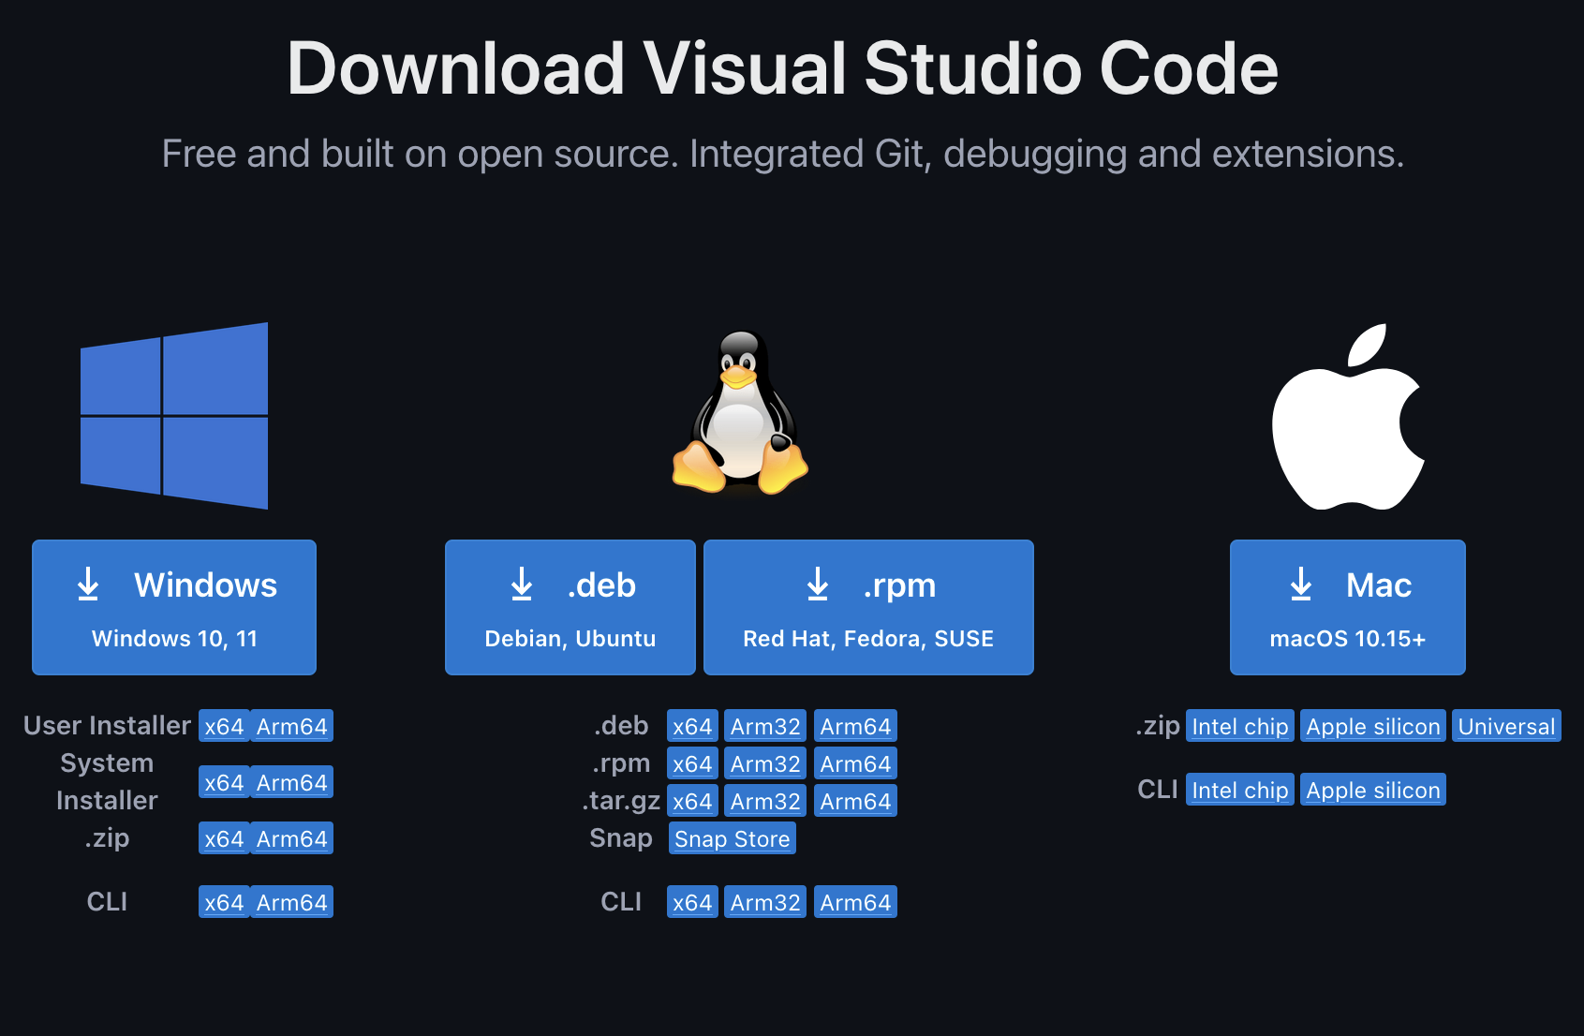

* Download the appropriate version for your system.
* Once downloaded, make sure to download these extensions.
  + SQLite Viewer

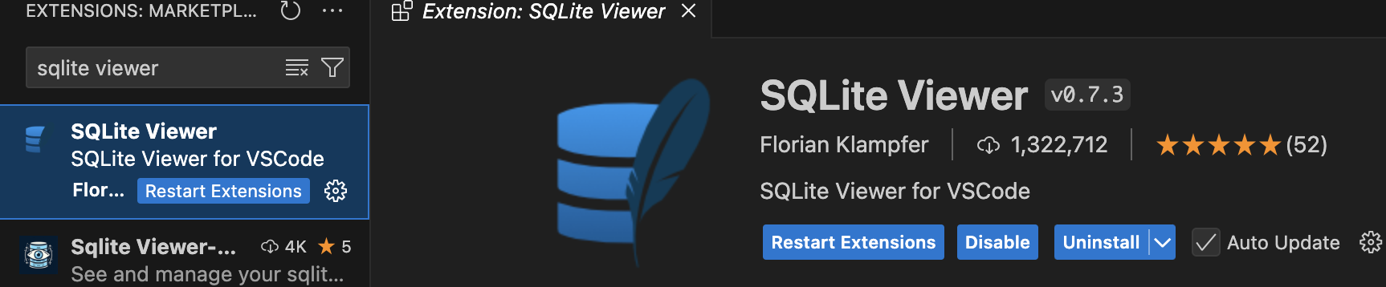

* + Docker
    - Note: this does not replace the desktop version!!

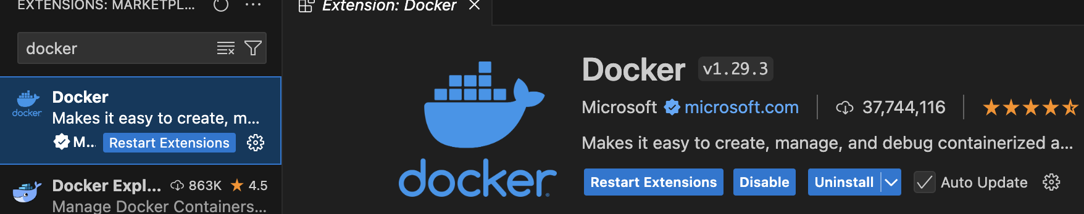

* Here is a guide to help you get familiar with VSCode
  + <https://code.visualstudio.com/docs/introvideos/basics>

## Command Line Tools

* In Ruby on Rails projects, you will need to use the command line often. For example, you will be starting your server using command line, using meta-programming to create entire classes using scaffolding and more!
* Windows OS
  + It is recommended that you use a tool such as PowerShell on Windows OS, as the default one tends to be problematic.
  + <https://learn.microsoft.com/en-us/powershell/?view=powershell-7.4>
    - Follow this link to get started!
* Mac OS
  + If you are on a mac, you have it a bit easier as the Terminal is already built in and easy to use!
    - Use Command + Space bar to bring up your search function
    - In the search bar, type Terminal

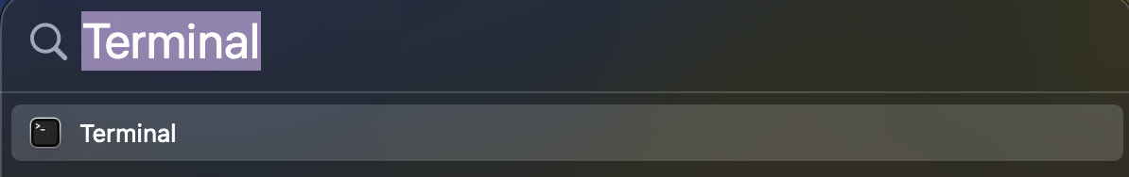

* + - Click on it, and you have your command line tool!

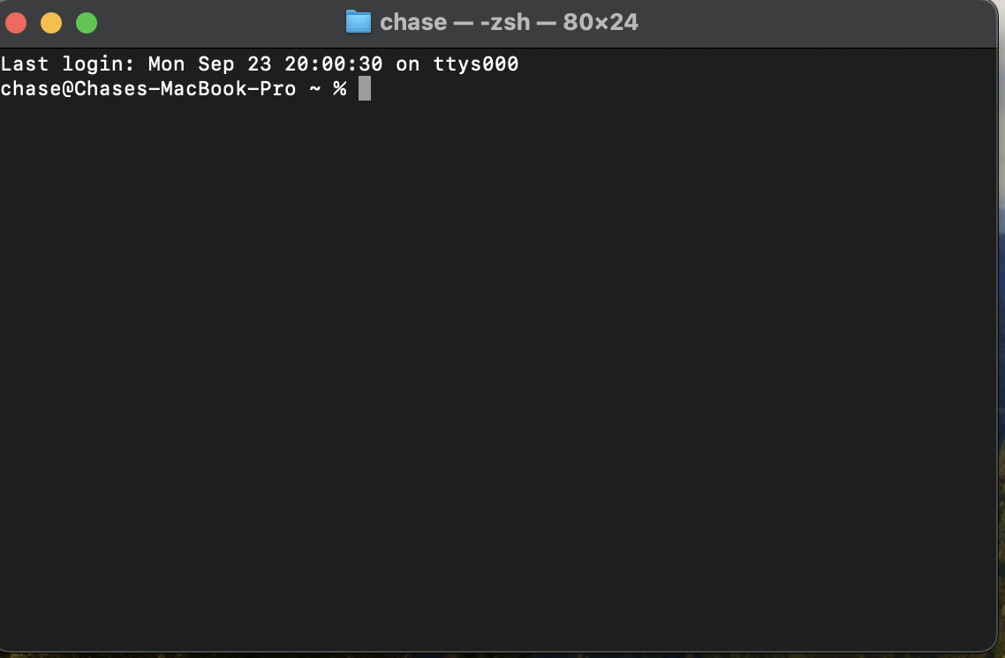

## Here is what the Terminal looks like!

## Docker

* Follow this link and download the Docker Desktop application
  + <https://docs.docker.com/get-started/get-docker/>
* Once downloaded, to familiarize yourself with Docker follow Docker’s guide of getting started with Docker
  + To test that docker is correctly installed, please test using
    - docker run -d -p 8080:80 docker/welcome-to-docker
      * This will download and create a container.
      * Your command line tool will look something like this

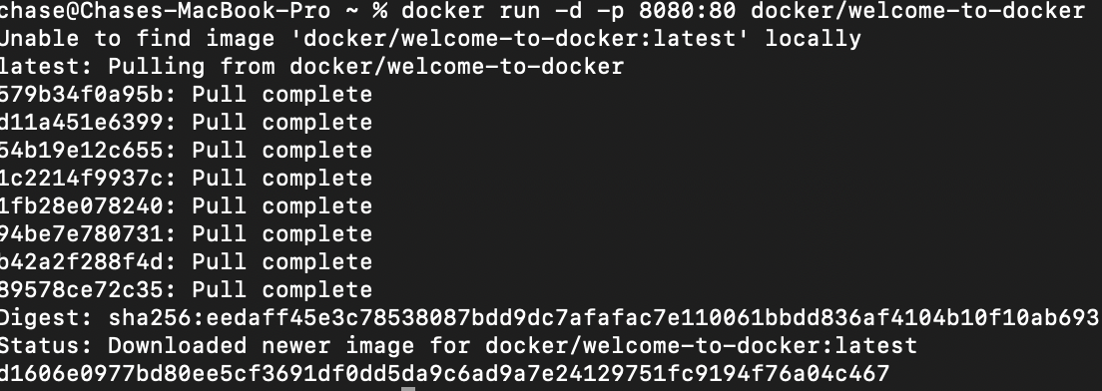

* + - This should bring up the following screen.



* + Now that you have ran your first container, familiarize yourself with docker by following the introduction on Docker’s website, linked below.
  + <https://docs.docker.com/get-started/introduction/>
* Now that you understand how docker works, it is time to create your own image to create your portfolio app in.
  + First, create a directory in your computer for your docker files.
    - Mine is named docker_build, so I know where all my docker stuff should be.

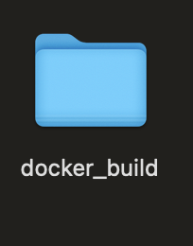

* + Second, you will visit the following link, download the resources and move them into the directory you just made.
    - <https://drive.google.com/drive/folders/1_Mg-8M8zw39ZyOa3DLpAn4AR0uaP_T8x>
  + Next, using your command line tool go into the directory you made with the new files included.
  + While inside this directory, try running this command with your information added
    - docker build –t [dockerUsername]/[image_name] .
    - For example, here is how mine looked
      * docker build –t [cblanco27]/[cs3710] .
    - If you are running into issues, please make sure everything is lowercase!
    - This command will build the image using the files provided and put into your directory.
  + Now it is time to run the newly created image!
    - Try the command
    - docker run –it –p 3000:3000 –v $(pwd):/workspace [dockerUsername]/[image_name]
      * For example, here is what mine looked like: docker run –it –p 3000:3000 –v $(pwd):/workspace [cblanco27]/[cs3710]
  + Congratulations, you just made a container! You will want to use this container continually, so here is how you open the same container every time!
    - Using the following command will show you what containers you currently have in docker.
      * docker ps –a



* + - * Here it shows the container ID as well as the name of all containers I currently have.
    - To open a container all you need to do is the following
      * Copy your desired container ID
      * Run the command: docker start [containerID]
        + For example, mine would be:

docker start 74d927ab4017



* + - If you are ever unsure of what container you have open, use the command ‘docker ps’ to check what is currently running!
* You should now have the tools to start working on your Ruby on Rails project using Docker!!